|  |  |  |  |
| --- | --- | --- | --- |
|  |  |  |  |
|  | Data |  |  |
| waterfront | Average of age | Count of id | Average of price per sqft |
| 0 | **43,2564617** | 21434 | 262,2863936 |
| 1 | 52,11042945 | 163 | 508,3298528 |
| Grand Total | **43,32328564** | 21597 | 264,1433684 |
|  |  |  |  |

The average price per sqft living with waterfront 508 is higher than a non-waterfront 262, despite the age of waterfront houses being older with 52.11yrs old vs the average age of 43.3.

The average price per sqft living @$280.75 are higher than the properties without renovation at @$266.72

The average price per sqft living ($326) is higher for the older houses compared to the ones built in the last 58yrs, which has a price average of $240.

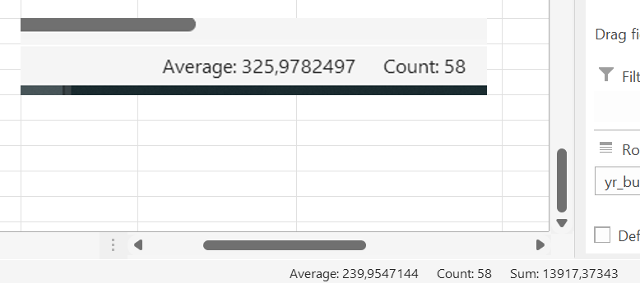

Irrespective of whether the Waterfront houses built before 1959 or after 1959 the price per sqft is $505.

 In 2008, Bellevue was number one in [CNNMoney](https://en.wikipedia.org/wiki/CNNMoney.com)'s list of the best places to live and launch a business,[[11]](https://en.wikipedia.org/wiki/Bellevue,_Washington#cite_note-11) and in 2010 was again ranked as the fourth-best place to live in America.[[12]](https://en.wikipedia.org/wiki/Bellevue,_Washington#cite_note-12) In 2014, Bellevue was ranked as the second-best place to live by *USA Today*.[[13]](https://en.wikipedia.org/wiki/Bellevue,_Washington#cite_note-13)

More than 145 companies have been located in Bellevue; companies currently headquartered there include [PACCAR Inc](https://en.wikipedia.org/wiki/Paccar), [T-Mobile](https://en.wikipedia.org/wiki/T-Mobile_US), and [Valve](https://en.wikipedia.org/wiki/Valve_Corporation). Technology company [Amazon](https://en.wikipedia.org/wiki/Amazon_(company)) was founded in Bellevue by [Jeff Bezos](https://en.wikipedia.org/wiki/Jeff_Bezos).

<https://en.wikipedia.org/wiki/Bellevue,_Washington>

**Bellevue is close to the action without being at its center**.

Both cities were founded in the late 1800s—Seattle in 1851 and Bellevue in 1869. Bellevue remained pretty rural until the first floating bridge was built in the 1940s, and while it's far from rural these days, it's still a bit more relaxed than Seattle. A second floating bridge was added in 1963 and the city began to boom. Today, Seattle has about 660,000 residents to Bellevue’s approximately 120,000.

Seattle is home to Amazon, Starbucks, Nordstrom, Seattle’s Best Coffee, and Tullys, but Bellevue has Costco’s headquarters as well as Paccar, T-Mobile, Expedia and it’s not very far at all from Redmond. Redmond is the location of Microsoft, Nintendo, and Valve Corp.